|  |
| --- |
| Poka Gamers |
| Firing Trainer |
| **3D GAME** |
| Version #01  All work Copyright © 2016 by Poka Gamers.  All rights reserved. |
| **Bridgiet Dhivya Joseph** |
|  |

|  |
| --- |
| March 11th 2016 |

Table of Contents

Version History 3

Game Overview 4

Game Play Mechanics 4

Camera 4

Controls 4

Saving and Loading 4

Interface Sketch 5

Menu and Screen Descriptions 6

Game World 7

Levels 7

Characters 7

Enemies 7

Items 8

Script 8

Scoring 8

Sound Index 9

Art / Multimedia Index 10

Future Features 11

# Version History

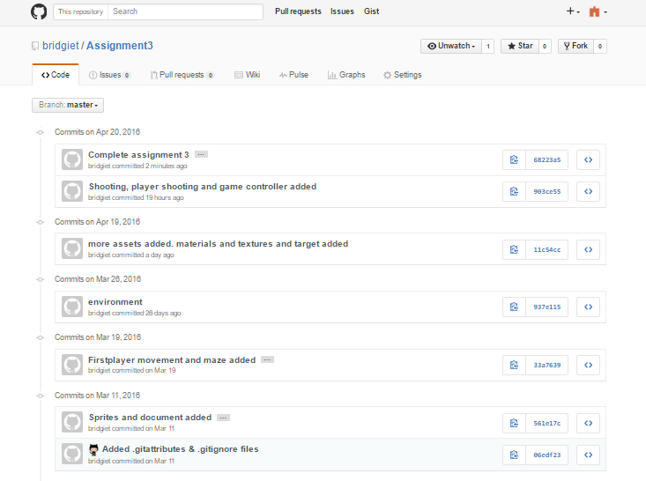

# Game Overview

*This game is a training game to shoot the targets within given number of bullets. The player has a gun by which he shoots. The aim of the game is to shoot all the targets present and keeping his life.*

# Game Play Mechanics

*If the player falls down from the plane, he looses his life by one. He has a maximum of 5 lives. By shooting on the targets he gains 100 points. He’s given only 25 bullets and 20 targets to shoot. On shooting on all the targets he wins.*

# Camera

*There is a Gun that follows the rifle.*

# Controls

*Left arrow / ‘a’ key – to move left*

*Right arrow / ‘d’ key – to move right*

*Click - Shoot*

# Saving and Loading

*Game doesn’t include saving and loading*

# Interface Sketch

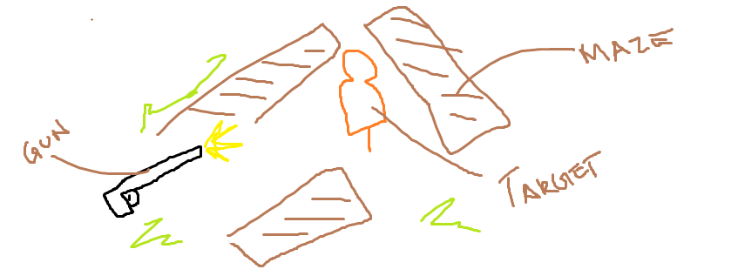

# Menu and Screen Descriptions

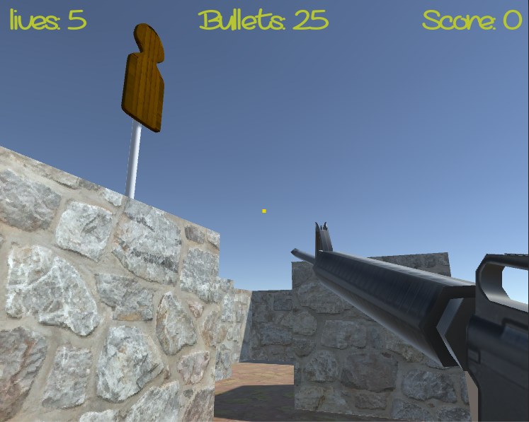

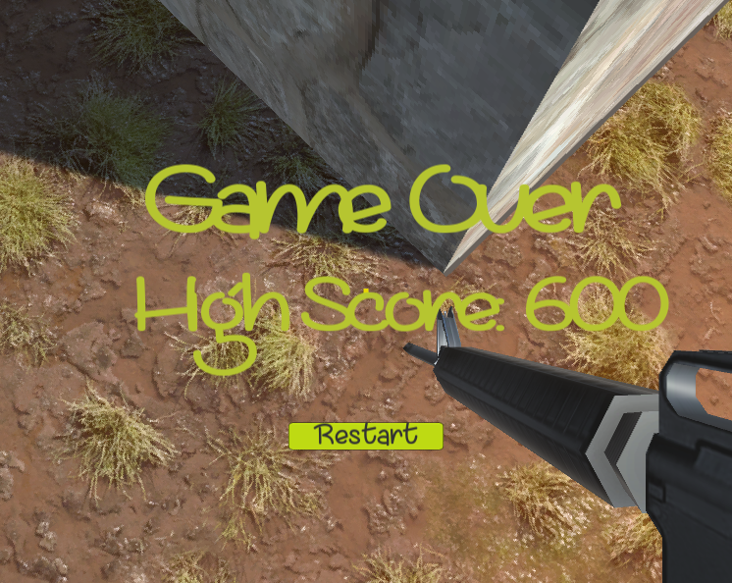

# Game World

*The environment consists of maze. The walls and rooftop of the maze are concrete.*

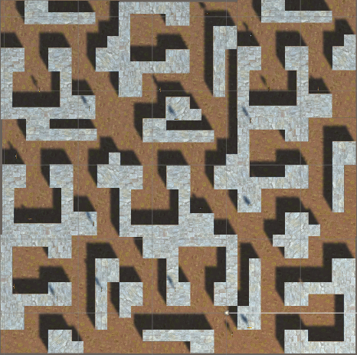

# Levels

*A single level same with the goal to reach the door. The next version will include additional levels with increased difficulty.*

# Characters:

Player:

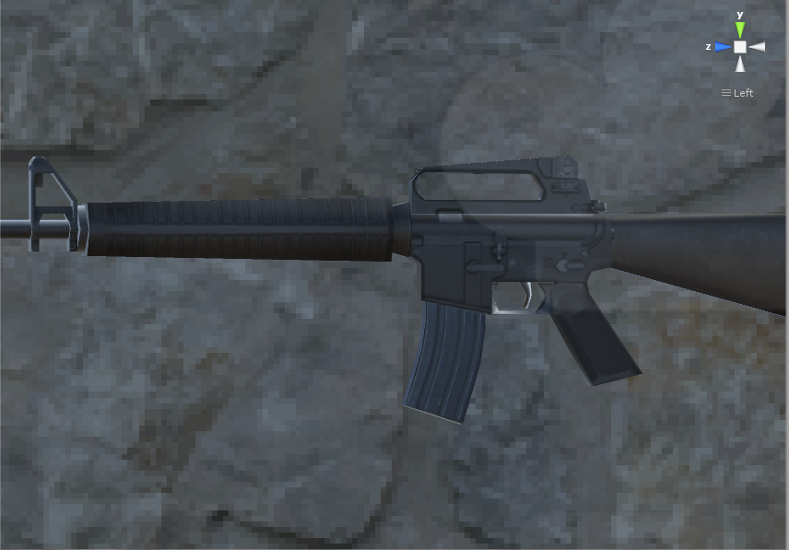

# Items

Target

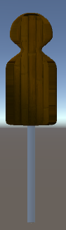

# Scoring

*The player gets 100 points for shooting at the targets*

*The player looses a life falling off the maze.*

*He loses if all his bullets are over.*

# Sound Index

|  |  |  |
| --- | --- | --- |
| *Index* | *Name* | *Description* |
| *1* | *fall* | *Fall sound* |
| *2* | *track* | *track* |

# Art / Multimedia Index

|  |  |  |  |
| --- | --- | --- | --- |
| *Index* | *Name* | *Type* | *Description* |
| *1* | *M16 Rifel* | *3D sprite* | *Player* |
| *2* | *Target* | *3D sprite* | *Gun Targets* |
| *3* | *Maze* | *3D sprite* | *Maze* |

# Future Features